# Bug 1 – Debugging Log

Hypothesis 1:

|  |  |
| --- | --- |
| Hypothesis | Balance is calculated incorrectly |
| Prediction | Balance total after adding players winnings is incorrect |
| Experiment | Run game and observe |
| Observation | Balance is decreased on loss correctly, balance does not increase correctly on any win condition of one two and three matches |
| Conclusion | Balance is calculated incorrectly, however problem is not identified, further investigation needed. |

Hypothesis 2:

|  |  |
| --- | --- |
| Hypothesis | Calculated balance only returns winnings and not bet amount |
| Prediction | Balance is only changed by winnings amount and does not return bet amount to the player |
| Experiment | Run game and observe |
| Observation | Winning never returns the players bet amount |
| Conclusion | No bet return within the Game.java, Game.playRound() method |

Bug Resolution:

To resolve the bug is to return the bet amount as well as winnings in line 49 of the Game class, Game.playround() method demonstrated in the below screenshots of before and after:

Before:

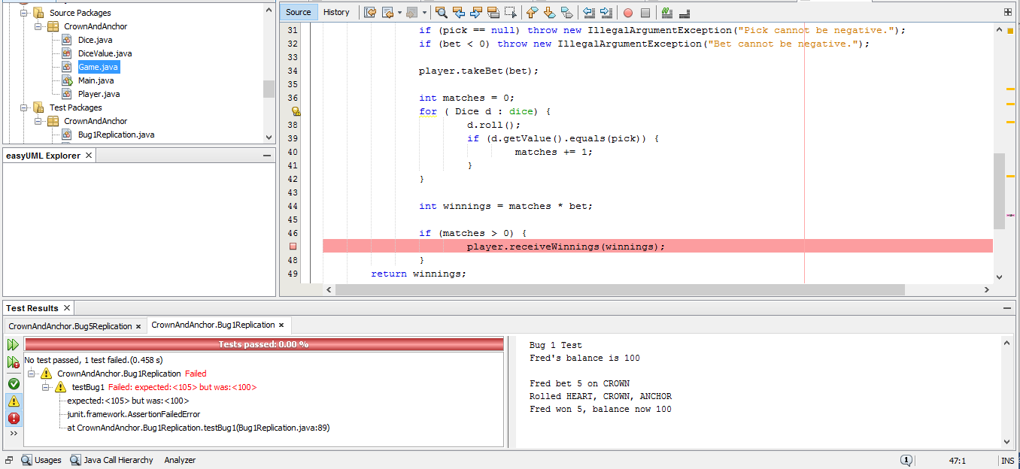

After:

